2. Draw the UML Diagram for Airport Management system An airport management system is a specialized digital platform that automates and streamlines the main airport operations including passenger processing, baggage tagging and handling, arrival/departure operations, departure control systems, information distribution, and air traffic control (ATC). Draw the Use case diagram, Class diagram, Activity diagram and Sequence diagram for Airport Management system.

**Solution:**

**Class Diagram:**

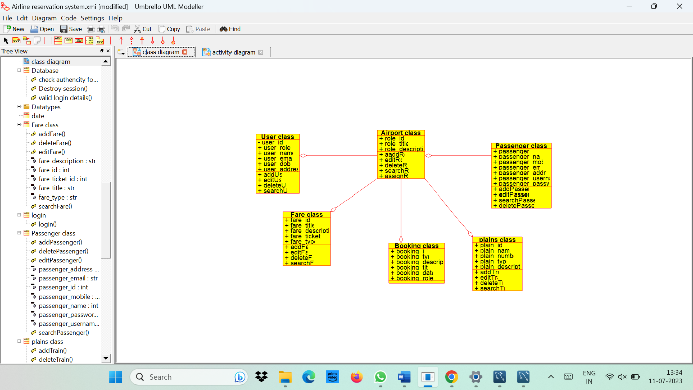

**Activity Diagram:**

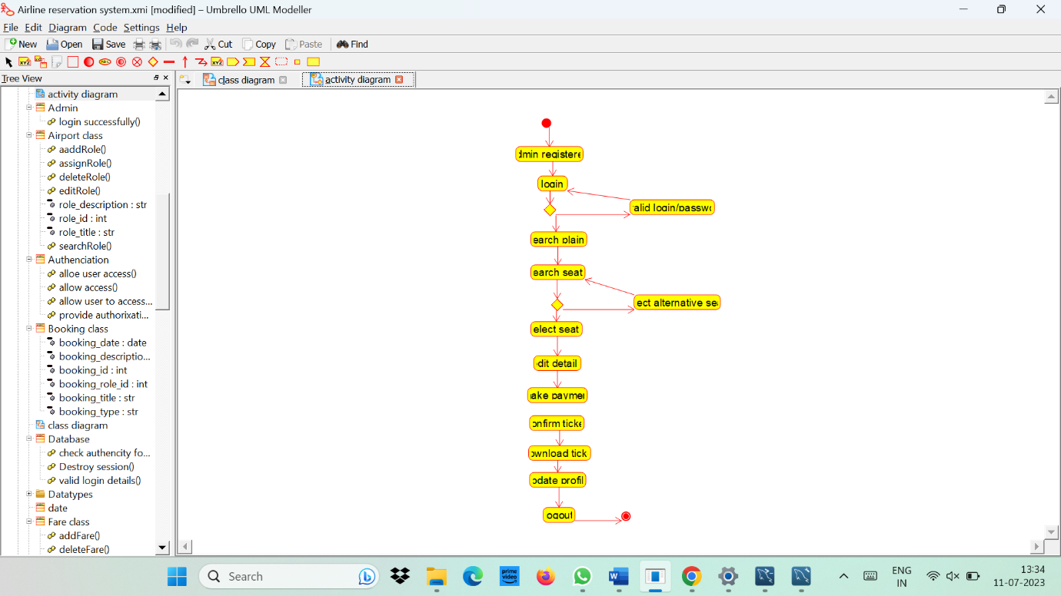

**Usecase Diagram:**

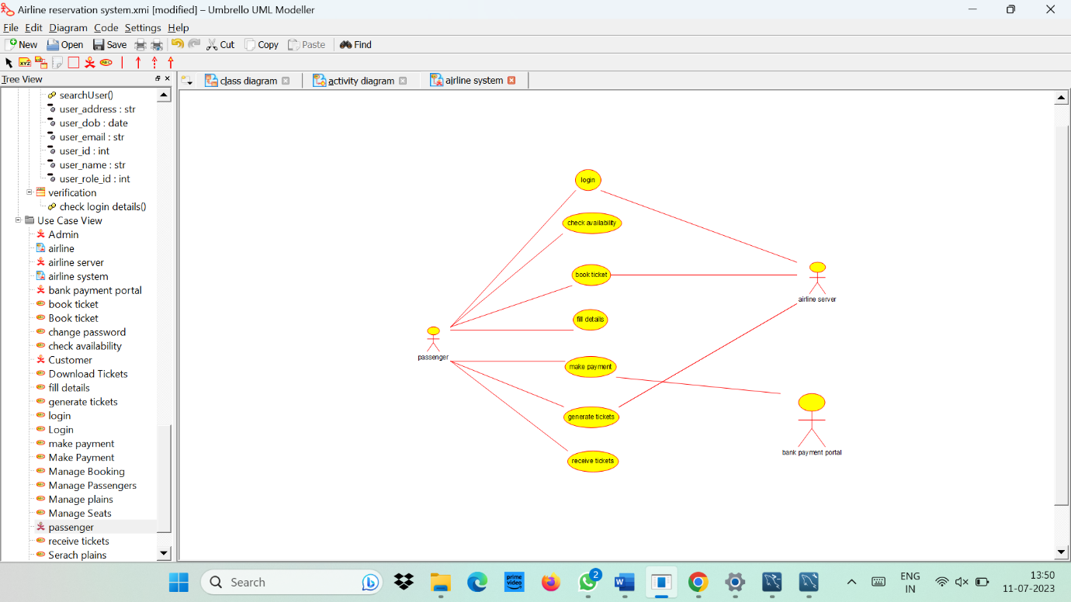

**Sequence Diagram:**

